1. **Go to this link and download visual studio :** [**https://visualstudio.microsoft.com/downloads/**](https://visualstudio.microsoft.com/downloads/)

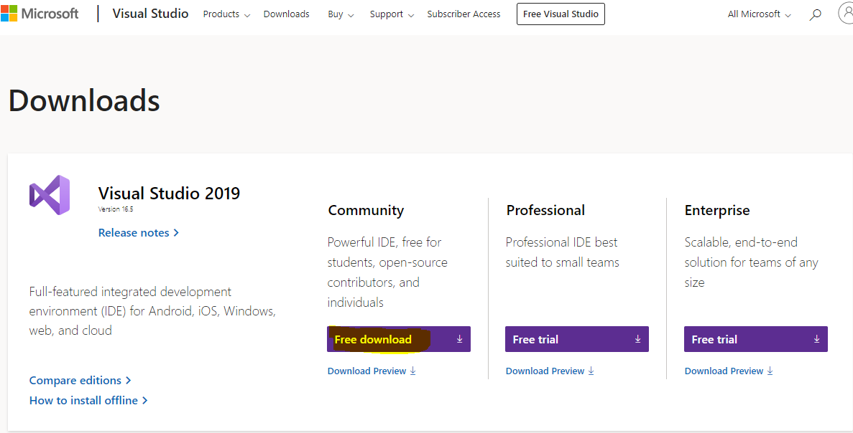

1. **Go to this link and download MSSQL Server:** <https://www.microsoft.com/en-us/sql-server/sql-server-downloads>

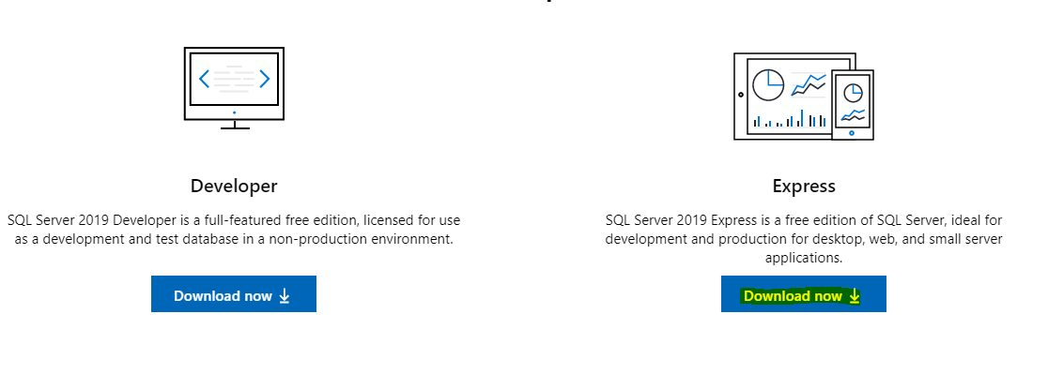

1. **Go to this link and Download SQL Server Management Studio (SSMS):** <https://docs.microsoft.com/en-us/sql/ssms/download-sql-server-management-studio-ssms?view=sql-server-ver15>

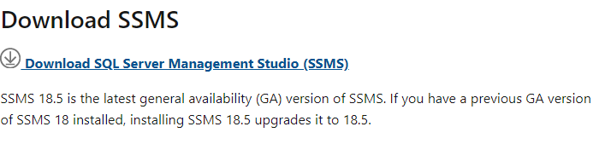

1. After install all these, download the code from Github: <https://github.com/hasanmukit009/CourseManagementSystem.git>
2. Open the project and Go to Toolbox>Package Manager Console

Run these following codes in console

1. Add-Migration initialmigration
2. Update-Database